MIS 6326.501 – Data Management - Assignment 5
Swetha Krishnakumar (sxk151530)

Assignment 5 SQL Fundamentals

Total points: 50

This assignment should be completed individually. For each problem, submit your SQL statement and a screen shot of the SQL results in a single Word document or pdf file. Submit the file via eLearning.

I recommend creating a new user and workspace, log in as that user and load the database script ourvideo_A2.sql (provided in this week's assignment folder).
Before you attempt to write any SQL queries, familiarize yourself with the database structure and data. I have provided a relational diagram and sample data for this database.
Write queries to address each of the problems below. Submit both the SQL statements and the screen prints of the outputs from Oracle.
OurVideo is a small movie rental company with a single store. OurVideo needs a database system to track the rental of movies to its members. OurVideo can own several copies (VIDEO) of each movie (MOVIE). For example, the store may have 10 copies of the movie “Twist in the Wind”. “Twist in the Wind” would be one MOVIE and each copy would be a VIDEO. A rental transaction (RENTAL) involves one or more videos being rented to a member (MEMBERSHIP). A video can be rented many times over its lifetime, therefore, there is a M:N relationship between RENTAL and VIDEO. DETAILRENTAL is the bridge table to resolve this relationship. The complete ERD is provided in the Figure below.
OurVideo ERD
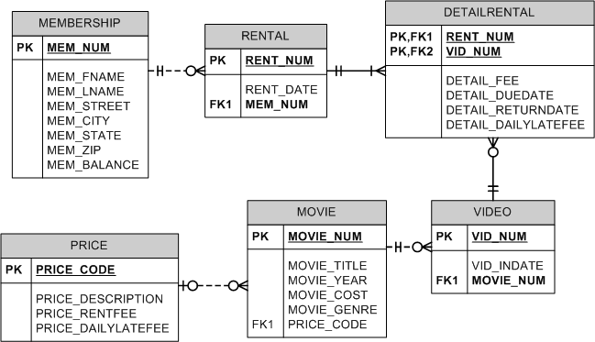

Each question is worth 5 points.

- Create sequences for the RENTAL and MEMBERSHIP tables. The MEMBERSHIP sequence should start with 100 and increment by 10 and the RENTAL sequence should start with 1 and increment by 1.

Solution:
CREATE SEQUENCE RENTAL_CODE_SEQ START WITH 1 INCREMENT BY 1 NOCACHE;
CREATE SEQUENCE MEM_CODE_SEQ START WITH 100 INCREMENT BY 10 NOCACHE;

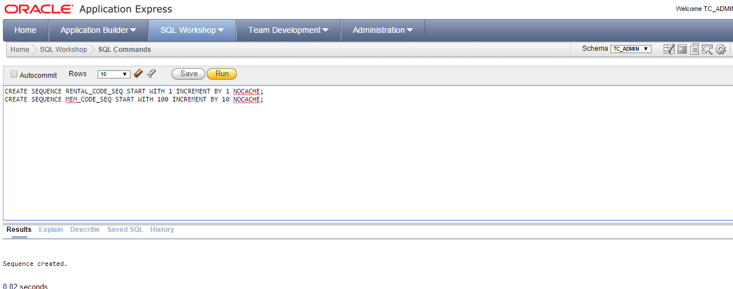

- What is the total movie cost for each movie genre? (order the results by total cost in descending order).

Movie_Genre | Total Cost
DRAMA | $175.39
ACTION | $105.44
COMEDY | $88.24
FAMILY | $39.95

Solution:

Select Movie_Genre,SUM(Movie_Cost) as "Total Cost" from Movie group by Movie_Genre order by "Total Cost" desc

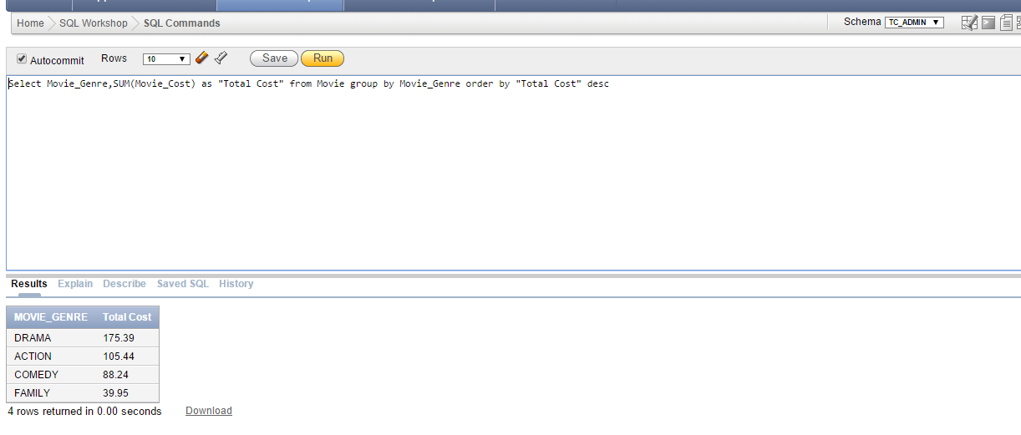

- Display the rental history for Tami Dawson, display the first and last name, rent date, due date, return date, and movie title.

MEM_FNAME | MEM_LNAME | RENT_DATE | DETAIL_DUEDATE | DETAIL_RETURNDATE | MOVIE_TITLE
TAMI | DAWSON | 03/02/0011 | 03/04/0011 | 03/09/0009 | The Cesar Family Christmas
TAMI | DAWSON | 03/02/0011 | 03/06/0011 | 03/09/0009 | What He Doesn't Know
TAMI | DAWSON | 03/02/0011 | 03/06/0011 | 03/09/0009 | Where Hope Dies

Solution:
Select Mem_FName, Mem_LName, r.Rent_Date, dr.Detail_DueDate, dr.Detail_ReturnDate, m.Movie_Title from Membership me inner join Rental r on r.Mem_Num = me.Mem_Num inner join DetailRental dr on dr.Rent_Num = r.Rent_Num inner join Movie m on m.Movie_Num = (Select Movie_Num from Video v where v.Vid_Num = dr.Vid_Num) where me.Mem_FName like UPPER('%Tami')

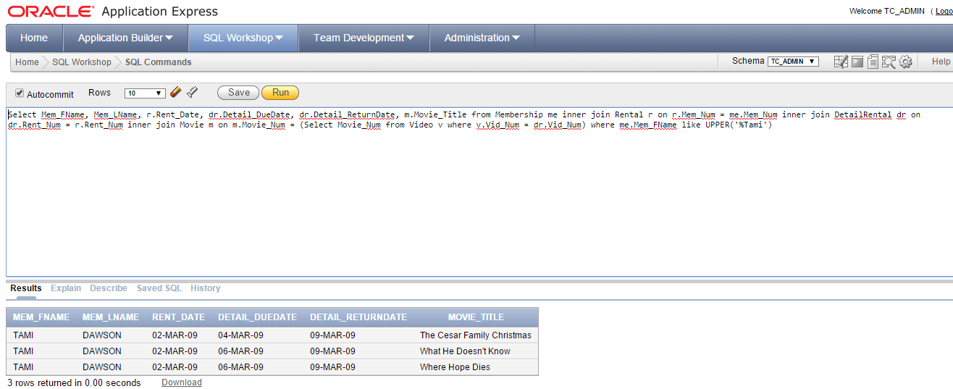

- Which members have come to the store and rented more than one video at a time? Show the members, the rent number, and the number of videos rented (only display the members who have rented more than 1 video at a time).

MEM_FNAME | MEM_LNAME | RENT_NUM | Videos Rented
LEWIS | ROSALES | 1004 | 3
CURT | KNIGHT | 1001 | 3
TAMI | DAWSON | 1003 | 3
STACY | MANN | 1005 | 2
ROSARIO | ELLIOTT | 1006 | 2

Solution:
Select me.Mem_FName, me.Mem_LName, r.Rent_Num, COUNT(dr.Rent_Num) as "Videos Rented" from Membership me inner join Rental r on r.Mem_Num = me.Mem_Num inner join DetailRental dr on dr.Rent_Num = r.Rent_Num group by me.Mem_FName, me.Mem_LName, r.Rent_Num having COUNT(dr.Rent_Num) > 1 order by COUNT(dr.Rent_Num) desc
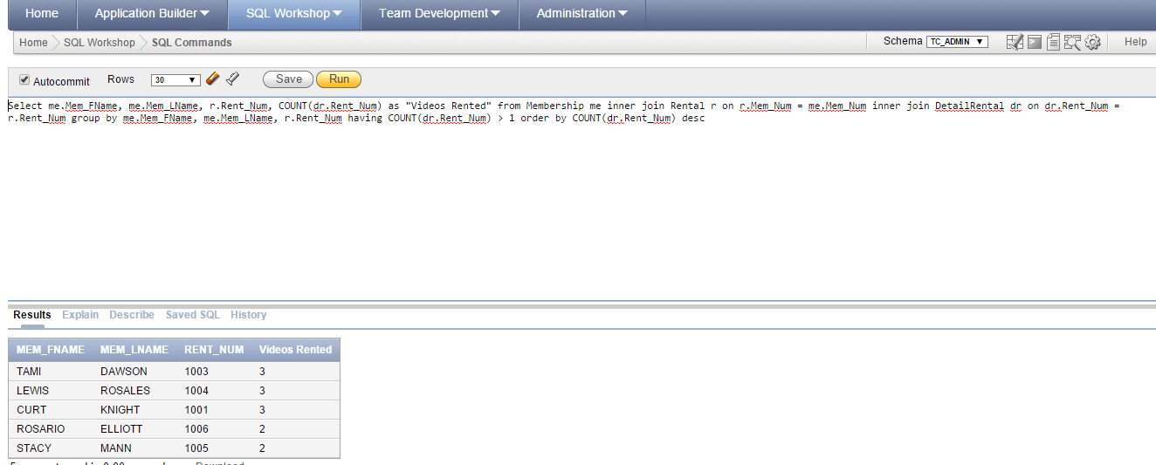

- Which movies have not been returned? Display the movie title, member name, rental date and due date.

MEM_FNAME | MEM_LNAME | RENT_DATE | DETAIL_DUEDATE | DETAIL_RETURNDATE | MOVIE_TITLE
STACY | MANN | 03/03/0011 | 03/05/0011 | - | The Cesar Family Christmas
ROSARIO | ELLIOTT | 03/02/0011 | 03/07/0011 | - | What He Doesn't Know
JAMAL | MELENDEZ | 03/02/0011 | 03/05/0011 | - | Richard Goodhope

Solution:
Select Mem_FName, Mem_LName, Rent_Date, Detail_DueDate,Detail_ReturnDate,Movie_Title from Membership me inner join Rental r on me.Mem_Num = r.Mem_Num inner join DetailRental dr on dr.Rent_Num = r.Rent_Num inner join Movie m on m.Movie_Num = (Select Movie_Num from Video v where v.Vid_Num = dr.Vid_Num) where dr.Detail_ReturnDate IS NULL

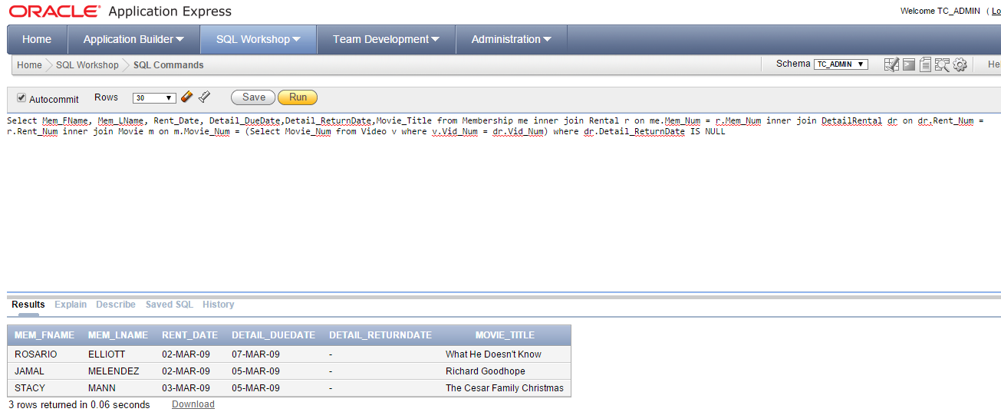

- Which movie titles have been rented out the most?

MOVIE_NUM | MOVIE_TITLE | Number of Rentals
1236 | Richard Goodhope | 5
1237 | Beatnik Fever | 3
1235 | Smokey Mountain Wildlife | 3
1246 | What He Doesn't Know | 2
1234 | The Cesar Family Christmas | 2
1245 | Time to Burn | 1
1239 | Where Hope Dies | 1

Solution:
Select m.Movie_Num,m.Movie_Title,COUNT(dr.Rent_Num) as "Number of Rentals" from Movie m inner join Video v on v.Movie_Num = m.Movie_Num inner join DetailRental dr on dr.Vid_Num = v.Vid_Num group by m.Movie_Num,m.Movie_Title order by COUNT(dr.Rent_Num) desc

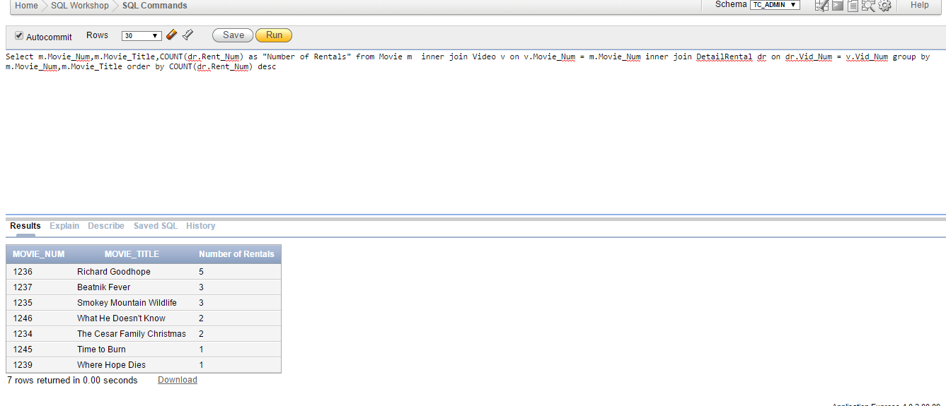

- Modify the query in question #6 to only display the movie that has been rented the most times (Hint: you are looking for MAX Number of Rentals. You will need to use a subquery on the Having clause)

MOVIE_NUM | MOVIE_TITLE | Number of Rentals
1236 | Richard Goodhope | 5

Solution:
Select m.Movie_Num,m.Movie_Title,COUNT(dr.Rent_Num) as "Number of Rentals" from Movie m inner join Video v on v.Movie_Num = m.Movie_Num inner join DetailRental dr on dr.Vid_Num = v.Vid_Num group by m.Movie_Num,m.Movie_Title having COUNT(dr.Rent_Num) IN (Select MAX(COUNT(DetailRental.Rent_Num)) from Movie inner join Video on Video.Movie_Num = Movie.Movie_Num inner join DetailRental on DetailRental.Vid_Num = Video.Vid_Num group by Movie.Movie_Num)

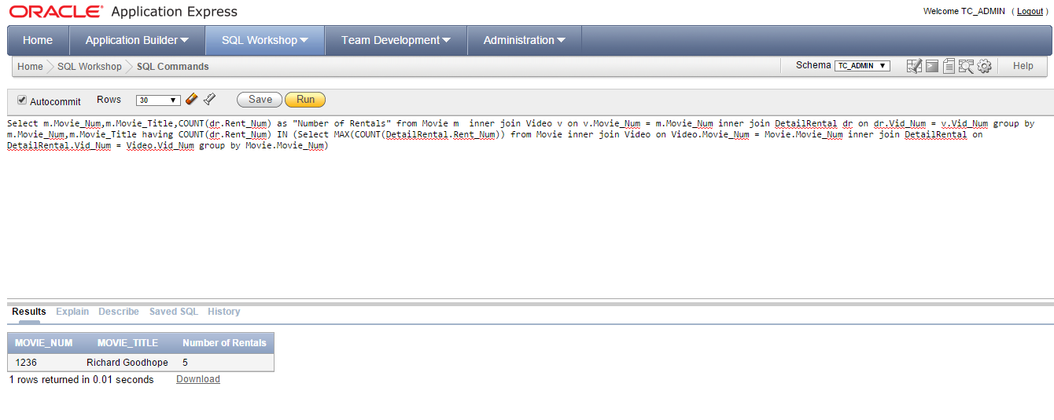

- Generate a list of Member ids using the first character of the first name, the first 4 characters of the last name, and the 2 characters of member state.

MEM_FNAME | MEM_LNAME | User ID
TAMI | DAWSON | TDAWSOTN
CURT | KNIGHT | CKNIGHKY
JAMAL | MELENDEZ | JMELENTN
IVA | MCCLAIN | IMCCLAKY
MIRANDA | PARKS | MPARKSTN
ROSARIO | ELLIOTT | RELLIOTN
MATTIE | GUY | MGUYKY
CLINT | OCHOA | COCHOATN
LEWIS | ROSALES | LROSALTN
STACY | MANN | SMANNTN
LUIS | TRUJILLO | LTRUJITN
MINNIE | GONZALES | MGONZATN

Solution:
Select Mem_FName,Mem_LName, SUBSTR(Mem_FName, 1, 1) || SUBSTR(Mem_LName, 1, 4) || Mem_State as "UserID" from Membership

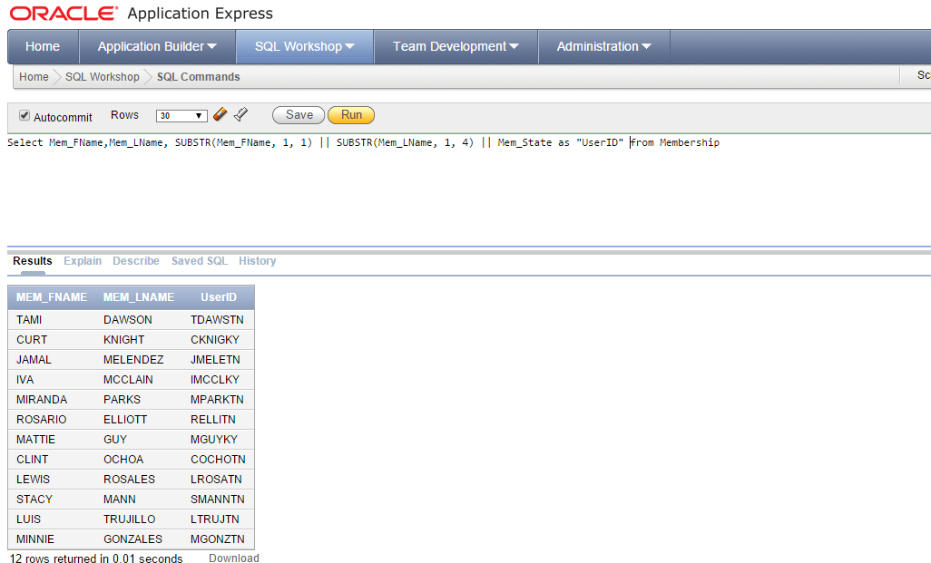

- Show the difference between each movie’s rental fee and the min movie price and the max movie price.

MOVIE_NUM | MOVIE_TITLE | MOVIE_GENRE | PRICE_RENTFEE | MINPRICE | MinDiff | MAXPRICE | MAXDiff
1245 | Time to Burn | ACTION | 2 | 1 | 1 | 3.5 | -1.5
1246 | What He Doesn't Know | COMEDY | 2 | 1 | 1 | 3.5 | -1.5
1235 | Smokey Mountain Wildlife | ACTION | 2 | 1 | 1 | 3.5 | -1.5
1236 | Richard Goodhope | DRAMA | 3.5 | 1 | 2.5 | 3.5 | 0
1234 | The Cesar Family Christmas | FAMILY | 3.5 | 1 | 2.5 | 3.5 | 0
1237 | Beatnik Fever | COMEDY | 3.5 | 1 | 2.5 | 3.5 | 0
1239 | Where Hope Dies | DRAMA | 1.5 | 1 | .5 | 3.5 | -2

Solution:
Select Movie_Num,Movie_Title,Movie_Genre,Price_RentFee,(Select MIN(Price_RentFee) from Price) as "MINPRICE",(Price_RentFee - (Select MIN(Price_RentFee) from Price)) as "MINDIFFERENCE", (Select MAX(Price_RentFee) from Price) as "MAXPRICE" ,(Price_RentFee - (Select MAX(Price_RentFee) from Price)) as "MAXDIFFERENCE" from Movie inner join Price on Price.Price_Code = Movie.Price_Code group by Movie_Num,Movie_Title,Movie_Genre,Price_RentFee order by Movie_Num

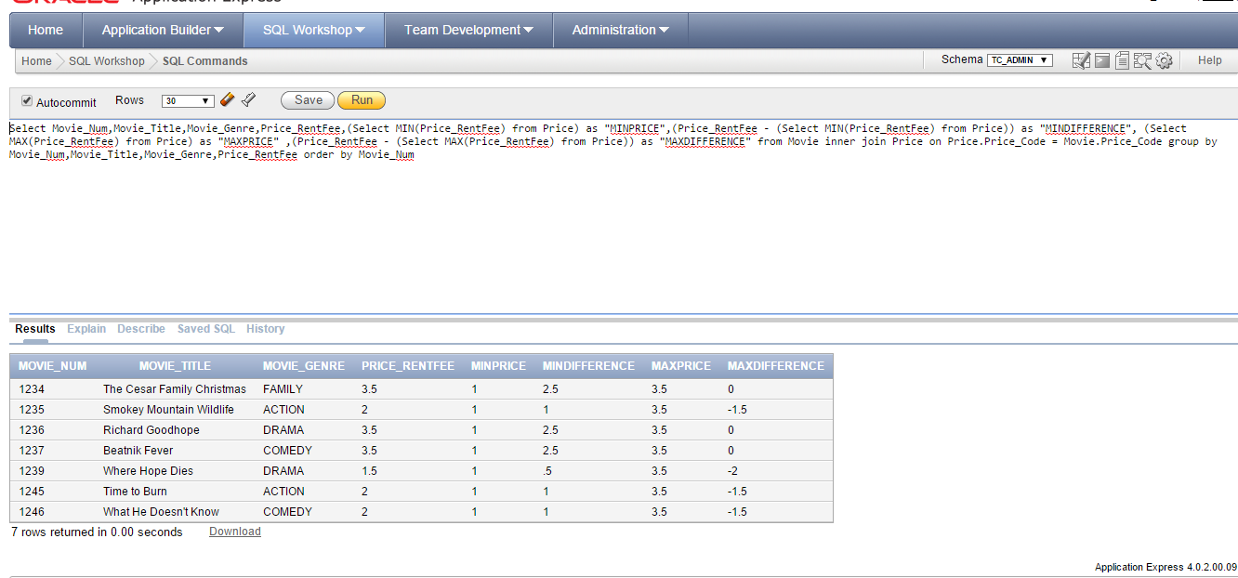

- Create a view that will produce the result set shown below. Call the view overdue_vw. (5 pts)
--After you have created the view, test the view by selecting all rows and columns from the view. Show the query and the output.
MEM_NUM | MEM_LNAME | RENT_NUM | VID_NUM | MOVIE_NUM | MOVIE_TITLE | RENT_DATE | DETAIL_DUEDATE | DETAIL_RETURNDATE
107 | ELLIOTT | 1006 | 61367 | 1246 | What He Doesn't Know | 03/02/0011 | 03/07/0011 | -
104 | MELENDEZ | 1007 | 34368 | 1236 | Richard Goodhope | 03/02/0011 | 03/05/0011 | -
111 | MANN | 1009 | 54324 | 1234 | The Cesar Family Christmas | 03/03/0011 | 03/05/0011 | -

Solution:
Create or Replace View Overdue_vw as
Select me.Mem_Num, Mem_LName, r.Rent_Num, v.Vid_Num, m.Movie_Num, Movie_Title, r.Rent_Date,dr.Detail_DueDate,dr.Detail_ReturnDate from Membership me inner join Rental r on me.Mem_Num = r.Mem_Num inner join DetailRental dr on dr.Rent_Num = r.Rent_Num inner join Video v on v.Vid_Num = dr.Vid_Num inner join Movie m on m.Movie_Num = v.Movie_Num where dr.Detail_ReturnDate IS NULL

Select * from Overdue_vw order by RENT_NUM
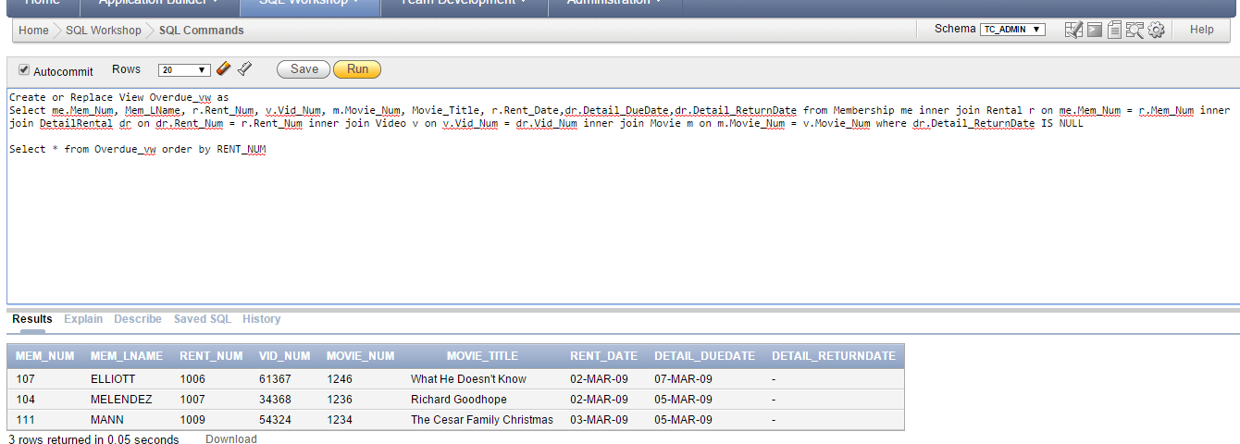

Extra Credit:
Alter the query in #10 to display the total amount due per rental detail, per customer.

MEM_FNAME | MEM_LNAME | RENT_NUM | DETAIL_DUEDATE | Overdue Fee
TAMI | DAWSON | 1003 | 03/06/0011 | $6.00
LEWIS | ROSALES | 1004 | 03/05/0011 | $14.00
TAMI | DAWSON | 1003 | 03/04/0011 | $17.50

Solution:
Create or Replace View Overdue_vw as
Select me.Mem_Num, Mem_FName, Mem_LName, r.Rent_Num, v.Vid_Num, m.Movie_Num, Movie_Title, r.Rent_Date,dr.Detail_DueDate,dr.Detail_ReturnDate,dr.Detail_DailyLateFee,dr.Detail_Fee from Membership me inner join Rental r on me.Mem_Num = r.Mem_Num inner join DetailRental dr on dr.Rent_Num = r.Rent_Num inner join Video v on v.Vid_Num = dr.Vid_Num inner join Movie m on m.Movie_Num = v.Movie_Num

Select Mem_FName,Mem_LName,Rent_Num,Detail_DueDate, '' || '$' || SUM(((TO_DATE(Detail_ReturnDate,'dd/mm/yyyy')-TO_DATE(Detail_DueDate, 'dd/mm/yyyy')) * Detail_Fee)) as "Overdue Fee" from Overdue_vw where (TO_DATE(Detail_ReturnDate,'dd/mm/yyyy') > TO_date(Detail_DueDate, 'dd/mm/yyyy')) group by Mem_FName,Mem_LName,Rent_Num,Detail_DueDate

